**MATRIX ACADEMY SCHOOL**

**CBSE AFFILIATION NO. 113029 SCHOOL NO. 30209**



ANNUAL PEDAGOGICAL PLAN

**ACADEMIC SESSION 2023-24**

**1.1. School Information :**

|  |  |
| --- | --- |
| **School Name** | MATRIX ACADEMY SCHOOL |
| **Address** | **Gulmohar Heritage, Kharodi Naka, Bolinj, Virar – West, Dist- Palghar -401303** |
| **Contact No.** | **7083620869** |
| **Email** | [**cbsematrixacademyschool5@gmail.com**](mailto:cbsematrixacademyschool5@gmail.com) |
| **Website** | [**www.matrixacademyschool.com**](http://www.matrixacademyschool.com) |
| **Name of the Principal** | **Mrs. Seema S. Behal** |
| **Year of Affiliation** | **2008** |
| **Affiliation No** | **1130296** |
| **School No** | **30209** |
| **Level of School** | **Senior Secondary** |
| **School Category** | **Co-Educational, Day School with Two Shifts** |
| **Total No. of Students:** | **Boys: 1716 Girls: 1439** |
| **CWSN** | **YES** |
| **Location** | **RURAL** |

**1.2.No of Students on Roll ( Class Wise ):**

|  |  |  |  |  |  |  |  |  |  |  |  |  |  |
| --- | --- | --- | --- | --- | --- | --- | --- | --- | --- | --- | --- | --- | --- |
| **Class** | **PP** | **I** | **II** | **III** | **IV** | **V** | **VI** | **VII** | **VIII** | **IX** | **X** | **XI** | **XII** |
| **Number of Sections** | **07** | **08** | **08** | **08** | **08** | **07** | **07** | **07** | **07** | **06** | **06** | **02** | **03** |
| **Students on Roll** | **307** | **343** | **354** | **346** | **336** | **299** | **308** | **286** | **270** | **221** | **238** | **57** | **97** |

**1.3.School Academic Performance :**

**a) Pass Percentage of 2022-23**

|  |  |  |  |
| --- | --- | --- | --- |
| **Class** | **No. of Students Appeared** | **No. of Students Passed** | **Pass Percentage** |
| **I** | **349** | **349** | **100** |
| **II** | **351** | **351** | **100** |
| **III** | **352** | **352** | **100** |
| **IV** | **296** | **296** | **100** |
| **V** | **319** | **319** | **100** |
| **VI** | **277** | **277** | **100** |
| **VII** | **274** | **274** | **100** |
| **VIII** | **226** | **226** | **100** |
| **IX** | **241** | **241** | **100** |
| **XI** | **103** | **101** | **98** |

**1.4. a)Toppers of AISSE 2022-23 :**

|  |  |  |
| --- | --- | --- |
| **Year** | **Name of the students** | **Percentage** |
| **2023** | **Patil Shalv Kshitij** | **98.6%** |
| **Yadav Akshansh Dharamveer** | **97.6%** |
| **Himanshu Kumar Singh** | **97.4%** |

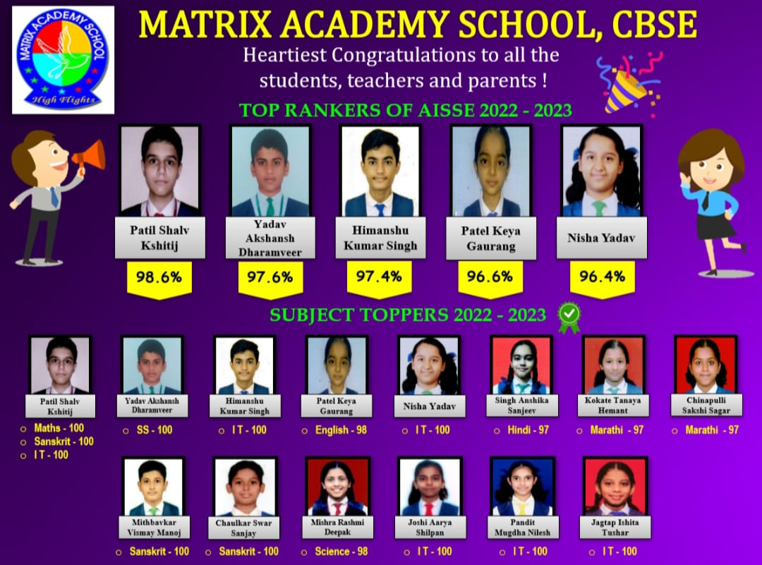

**b) Toppers of AISSCE 2022-23**

|  |  |  |
| --- | --- | --- |
| **Year** | **Name of the students** | **Percentage** |
| **2023** | **Sarang Patil** | **93%** |
| **Rishi Mane** | **92.8%** |
| **Preksha Trivedi** | **92.8 %** |
| **Kimaya Zagade** | **90.6%** |

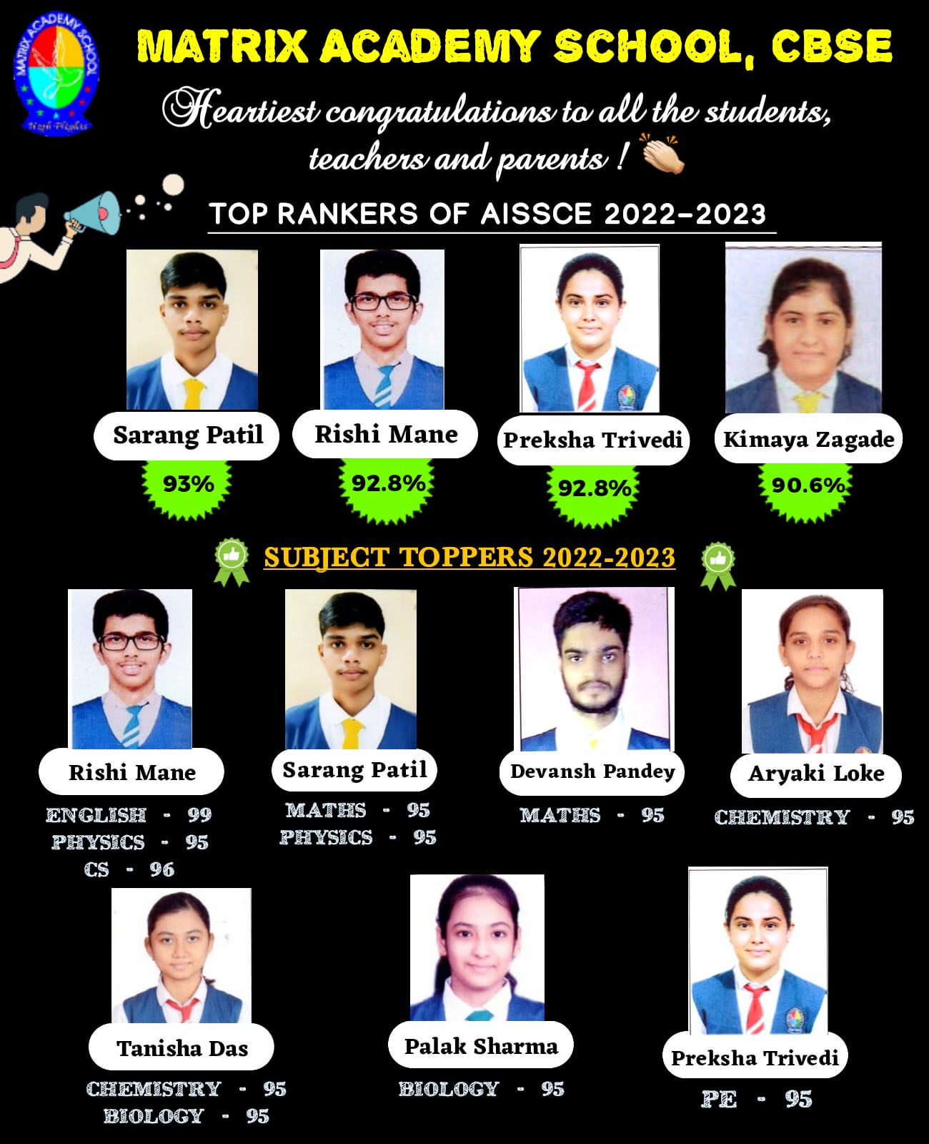

**1.5. Key Strength of School:**

1. **Academic Excellence:** A strong focus on high-quality teaching and learning, rigorous curriculum, and effective assessment methods to ensure students achieve academic success and reach their full potential.
2. **Dedicated and Qualified Faculty:** A team of skilled and passionate educators who are committed to providing engaging instruction, individualized support, and mentorship to students.
3. **Holistic Education:** A well-rounded educational approach that goes beyond academics to develop students' social, emotional, physical, and creative abilities. This includes extracurricular activities, sports, arts, and character development programs.
4. **Safe and Supportive Environment:** A positive and inclusive school climate that fosters a sense of belonging, respect, and emotional well-being. Schools that prioritize the physical and emotional safety of their students create an optimal learning environment.
5. **Parent and Community Involvement:** Strong partnerships between the school, parents, and the wider community. Active involvement and collaboration with parents, community organizations
6. Enhance students' educational experiences and provide additional resources and support.
7. **Technology Integration:** Effective utilization of technology in teaching and learning processes to enhance student engagement, facilitate personalized learning, and develop 21st-century skills.
8. **Cultural Diversity and Global Perspective:** Embracingdiversity and promoting intercultural understanding to prepare students for a multicultural society and global citizenship. Schools that value and celebrate diversity create an inclusive and enriching environment for all students.
9. **Continuous Improvement:** A commitment to ongoing assessment, evaluation, and professional development to continuously enhance teaching practices, curriculum, and school policies.

**1.6.Staff list :**

|  |  |
| --- | --- |
| **Group** | **Number of Regular / Trained Staff** |
| **Pre-Primary** | **07** |
| **Primary** | **49** |
| **Secondary** | **46** |
| **Senior Secondary** | **07** |
| **PET** | **04** |
| **Librarian** | **01** |
| **Music Teacher** | **04** |
| **Dance Teacher** | **03** |
| **Yoga Teacher** | **01** |
| **Counsellor** | **01** |
| **Total** | **123** |

**ANNUAL PEDAGOGICAL PLAN 2023- 2024**

**1.7. Pedagogical Plan Committee:**

|  |  |  |
| --- | --- | --- |
| **NAME** | **DESIGNATION** | **ROLE IN PPC** |
| **Mrs. Seema S. Behal** | **Principal** | **Planning** |
| **Mrs. Jeyanthi Ravichandran** | **Headmistress(Sr Secondary)** | **Co-ordinating** |
| **Mrs. Reshma Suvarna** | **Headmistress(Pre-Primary)** | **Co-ordinating** |
| **Mrs. Sandhya Mhatre** | **Supervisor (Secondary )** | **Co-ordinating** |
| **Mrs. Vaibhavi Salvi** | **Supervisor(Middle School)** | **Co-ordinating** |
| **Mrs. Swati Ganguly** | **Co-ordinator (Primary)** | **Co-ordinating** |
| **Mrs. Padma Ramesh** | **Supervisor(Primary)** | **Co-ordinating** |

**1.8.Vision, Mission, Values, Focus &Approach :**

* **Vision:**

The school envisions an inclusive learning community that empowers students to become lifelong learners, critical thinkers and compassionate global citizens.

**Our Vision:** We strive to cultivate a conducive environment that fosters academic excellence, creativity and innovation.

We aim to inspire the students to reach their fullest potential and make positive contributions to the world.

* **Mission:**

Providing a transformative educational experience:

* To prepare the students as all rounded individuals so that they succeed in the ever-changing world.
* To foster character building, critical thinking, effective communication and confident collaboration.
* To embrace diversity, promote social responsibility and cultivate leadership skills.
* To shape the future leaders and create a positive impact in the community and beyond.
* **Values:**

1. **Respect:** Treating oneself, others, and the environment with dignity, fairness, and kindness
2. **Self-Discipline**: Controlling self on all occasions with will power to overcome the challenges
3. **Integrity**: Demonstrating honesty, trustworthiness, and ethical conduct in all actions and interactions
4. **Excellence:** Pursuing high standards of academic achievement, personal growth, and continuous improvement
5. **Collaboration**: Fostering teamwork, cooperation, and effective communication among students, staff, and the wider community
6. **Responsibility:** Taking ownership of one's actions, being accountable, and fulfilling commitments
7. **Diversity and Inclusion**: Valuing and embracing the diverse backgrounds, perspectives, and experiences of individuals and promoting inclusivity and equality
8. **Empathy and Compassion**: Cultivating a caring and empathetic community that seeks to understand and support others
9. **Resilience**: Developing the ability to overcome challenges, adapt to change, and persevere in the face of obstacles

10.**Creativity:** Encouraging innovation, critical thinking, problem-solving, and artistic expression

11.**Environmental Stewardship**: Promoting sustainability, environmental awareness, and responsible use of resources

These values serve as a moral compass for the school community and help create a positive and nurturing environment conducive to learning, personal growth, and character development.

**Focus:**

1. **Academic Excellence**: A strong focus on providing rigorous and high-quality academic programs that prepare students for higher education or future careers. This includes a focus on core subjects like Maths, Science, Language arts, and Social Sciences.
2. **Holistic Development**: A comprehensive approach to education that emphasizes the development of students' social, emotional, physical, and creative abilities

This involves incorporating extracurricular activities, character education, and wellness programs into the curriculum.

1. **STEM Education**: A specific focus on Science, Technology, Engineering, and Mathematics (STEM) subjects to prepare students for careers in fields such as engineering, computer science, and scientific research.

Visits to STEM-related industries, communicating with them and Hands-on learning experiences help them to widen their knowledge.

1. **Arts and Creativity**: A focus on promoting artistic expression, creativity, and cultural appreciation through programs in visual arts, music, drama, dance, and other creative disciplines.

This includes dedicated art classes, performances, and opportunities like EBSB (Ek Bharat Shreshta Bharat) for students to showcase their talents on various platforms

1. **Global Citizenship and Cultural Awareness**: A focus on preparing students to be informed, culturally aware, and responsible global citizens

This involves multicultural education, foreign language programs, exchange programs, and service-learning initiatives with a global perspective.

1. **Technology Integration**: A focus on integrating technology into teaching and learning process to enhance student engagement, foster digital literacy, and prepare students for the digital age.

This ensures digitalized class rooms, the use of educational apps, online resources, and technology-infused classrooms.

1. **Community Engagement and Service**: A focus on fostering connections with the local community and instilling a sense of civic responsibility in students.

This is derived in community service projects like visit to Old age homes, Orphanages sharing lots of love and care with philanthropic actions, partnerships with local organizations, and opportunities for students to actively contribute to their communities.

**1.9. School’s Teaching Learning Approach:**

1. **Student-Centered Approach**: This approach emphasizes active, joyful learning, student engagement, and critical thinking.

Teachers act as facilitators, guiding students in their exploration of topics, encouraging collaboration, and providing opportunities for independent thinking, decision making and problem-solving.

1. **Project-Based Learning (PBL):** PBL involves students working on extended, real-world projects that require them to apply their knowledge and skills to solve complex problems. It promotes hands-on learning, collaboration, and the development of critical thinking, creativity, and communication skills.
2. **Inquiry-Based Learning**: This approach centers on students' ability to ask questions, investigate, and seek answers. Students actively explore topics, formulate questions, conduct research, and develop a deep understanding of concepts through their own discoveries. Teachers facilitate the process by providing guidance and resources.
3. **Blended Learning**: Blended learning combines traditional face-to-face instruction with online or digital resources. It provides a mix of in-person and online learning experiences, allowing students to engage with content and complete activities both in the classroom and through online platforms.
4. **Flipped Classroom**: In a flipped classroom, students learn the foundational content outside of class through videos, readings, or online modules. Class time is then dedicated to discussions, problem-solving, and applying knowledge under the guidance of the teacher. The flipped classroom model encourages active learning and student engagement.
5. **Montessori Approach**: The Montessori approach emphasizes individualized learning and hands-on exploration. It provides a prepared environment with a wide range of materials and activities that cater to each student's developmental needs and interests. The teacher acts as a guide, observing and facilitating the learning process.
6. **Reggio Emilia Approach**: This approach emphasizes the importance of child-led learning, creativity, and collaboration. Students are encouraged to explore their interests and express their ideas through various projects and mediums. The teacher acts as a co-learner and facilitator, documenting students' progress while providing constant support.

**1.10. Infrastructure :**

|  |  |
| --- | --- |
| **1.** | **Computer Lab.** |
| **2.** | **Biology Lab** |
| **3.** | **Chemistry Lab** |
| **4.** | **Physics Lab** |
| **5.** | **Maths Lab** |
| **6.** | **Coding & Robotics Lab** |
| **7.** | **Library** |
| **8.** | **Digiboard Enable Classrooms** |
| **9.** | **Play Ground** |
| **10.** | **Sports Room** |
| **11.** | **Dance Room** |

**ANNUAL CURRICULUM 2023 - 24**

**Curriculum Planning and Transaction:**

* **Curriculum Design and Development:**
  + Identify the educational goals, vision, and mission of the school.
  + Determine the desired learning outcomes for students.
  + Develop the curriculum framework, including subject areas, grade levels, and scope and sequence.
  + Align the curriculum with educational standards or guidelines set by CBSE.
* **Unit Planning:**
  + Break down the curriculum into units or modules based on specific topics or themes.
  + Determine the learning objectives and desired outcomes for each unit.
  + Plan the sequence of topics, activities, and assessments within each unit.
  + Consider different teaching strategies, resources, and materials to support student learning.
* **Lesson Planning:**
  + Break down each unit into individual lessons.
  + Define the learning objectives and outcomes for each lesson.
  + Select appropriate teaching methods, instructional strategies, and resources.
  + Design assessments or formative checks to monitor student progress and understanding.
* **Instructional Delivery**:
  + Deliver the lessons to students, ensuring engagement, clarity, and relevance
  + Use a variety of teaching strategies, such as lectures, discussions, demonstrations, group work, and hands-on activities
  + Adapt instruction based on student needs, abilities, and learning styles. Utilize technology and other educational resources to enhance teaching and learning
* **Assessment and Evaluation:**
  + Implement various forms of assessments as per the level of the students, including quiz, tests, projects, presentations, and portfolios, to evaluate student learning.
  + Provide timely and constructive feedback to students on their progress and areas for improvement.
  + Use assessment data to inform instructional decisions and adjust teaching strategies as needed.
  + Review and analyze assessment results to evaluate the effectiveness of the curriculum and instructional practices.
* **Reflection and Revision:**
  + Reflect on the effectiveness of the curriculum and instructional strategies used.
  + Seek feedback from students, teachers, and other stakeholders.
  + Identify areas for improvement and make necessary revisions like remedial classes as per the students’ excellence to the curriculum.
  + Continuously review and update the curriculum based on educational research, best practices, and changing